Centre for Psychosocial Research in Cancer (CentRIC+)

End of Study Checklist

(for Projects using CentRIC+ Datasets)

Version 1.0

March 2023

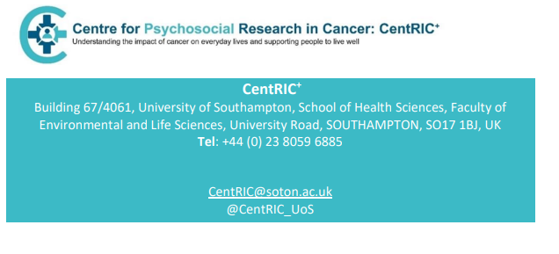

Please complete the checklist below when your study is complete. The end of the study is defined as when a paper has been accepted for publication or, 12 months after receipt of the dataset, at the discretion of the CentRIC+ Director or project Chief Investigator.

Please send the completed form to [CentRIC@soton.ac.uk](mailto:CentRIC@soton.ac.uk).

**CHECKLIST**

Name of principal applicant:

Title of project:

CentRIC+ dataset:

|  |  |
| --- | --- |
| I have returned the dataset to CentRIC+ including any derived variables |  |
|  |  |
| All local copies of the dataset have been deleted |  |
|  |  |

Signature: Date: