Centre for Psychosocial Research in Cancer (CentRIC+)

Research Progress Form

(for Projects using CentRIC+ Datasets)

Version 1.0

March 2023

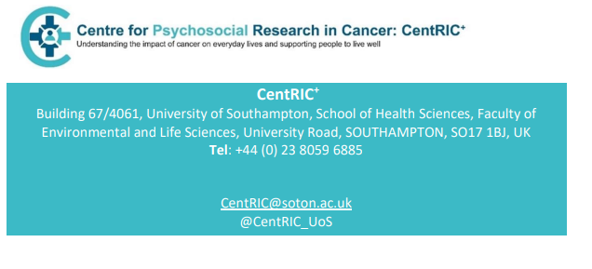

**This form should be completed 12 months after receiving CentRIC+ data if the project has not ended. Please email the completed form to** [**CentRIC@soton.ac.uk**](mailto:CentRIC@soton.ac.uk)**.**

**1. Applicants**

|  |  |  |
| --- | --- | --- |
| Principal applicant | Name: |  |
|  | Affiliation: |  |
|  | Email: |  |
|  | Telephone: |  |
|  | Address: |  |
|  |  |  |
| Co-applicant 1 | Name: |  |
|  | Email: |  |
| Co-applicant 2 | Name: |  |
|  | Email: |  |
| Co-applicant 3 | Name: |  |
|  | Email: |  |
| Co-applicant 4 | Name: |  |
|  | Email: |  |
| Co-applicant 5 | Name: |  |
|  | Email: |  |

*Add more rows if necessary*

**2. Project**

|  |  |
| --- | --- |
| CentRIC+Dataset: |  |
| Project title: |  |
| Date received data: |  |

**3. Progress report**

Please provide information, of no more than 2 pages in length, about progress made, any difficulties encountered, whether you wish to continue the project and if so, an estimated end date.

|  |
| --- |
|  |

**4. Signature**

Please sign below to certify that the details you have provided are correct.

|  |  |
| --- | --- |
| Signature: |  |
| Date: |  |
| Name (on behalf of applicants) |  |